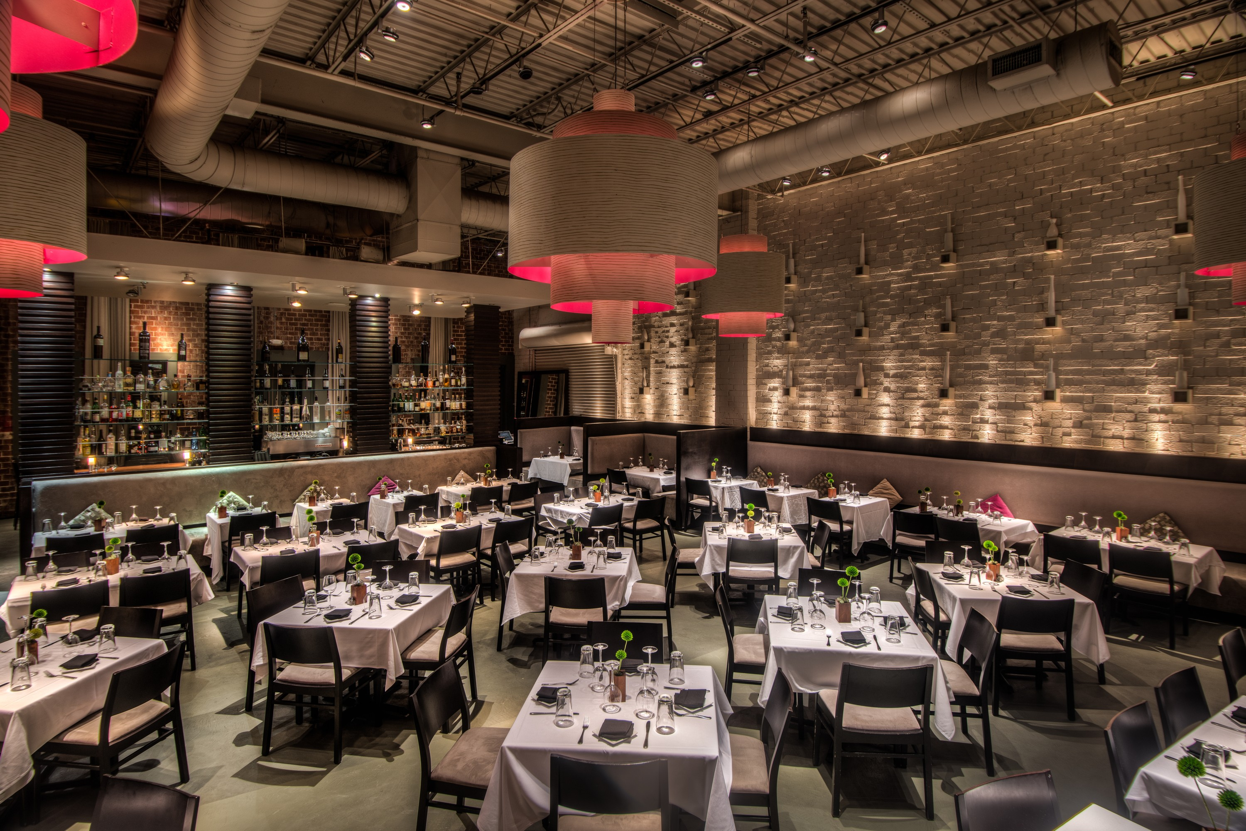

Rathbun’s is owned and operated by Rathbun’s Restaurants which include nationally recognized restaurants such as, Rathbun’s, Krog Bar, Kevin Rathbun Steak & KR SteakBar.

Located directly on the Atlanta Beltline, and in one the hottest areas of the city, (Inman Park) Rathbun’s was the lone trailblazer in 2004 when they entered the area. Inman Park is now home to some of the best places to live and dine in the City of Atlanta.

About Kevin Rathbun:

Kevin is an Iron Chef American and Food Network Chopped winner. When he went up against Bobby Flay in Iron Chef American, Kevin and his brother, Kent took home the winning recognition.

From 1995-2003, Chef Kevin was the Corporate Executive Chef for the Buckhead Life Restaurant Group, and oversaw many of the restaurants. In May of 2004, Chef Kevin opened his signature restaurant, Rathbun’s, in the Inman Park area of Atlanta. In October, 2005, we opened Krog Bar in the same complex as Rathbun’s. In 2007, Kevin Rathbun Steak opened and has become a nationally recognized steakhouse and has been named one of the Best Steakhouses in American four times over by several magazines. In 2013, KR SteakBar opened in Buckhead and has become one of the best Italian Steakhouses in Atlanta.

Private Dining Room

Rathbun's Private Dining Room is as dramatic as the rest of the restaurant.

The private dining room holds up to 40 people seated and up to 75 people for a cocktail style reception. We can seat guests in round or rectangular tables or seat up to 100 people on the covered patio.

It features its own Krog Street Wine Wall, and three French doors that overlook the patio. Reserve the room for business functions, presentation dinners, rehearsal dinners.

About Rathbun’s:

“Best New American Restaurants” by Travel and Leisure Magazine
“Best New Restaurant” by Esquire Magazine
“Restaurant of the Year” by Atlanta Magazine
“Best New Restaurant” by Creative Loafing.

A “Top Three Restaurant” from Jezebel Magazine

Featured in USA TODAY as a “New Gourmet Selection of Restaurants”

Bon Appetit Magazine as “Where to Eat Now” and a Bon Appetit “Hot 50 Restaurants”

“Best New Restaurant” by Jezebel Magazine, “Four Stars” by the Atlanta Journal Constitution.

Rathbun’s was chosen from Bon Appetit under “What’s Hot & Where the

Knowing are Going

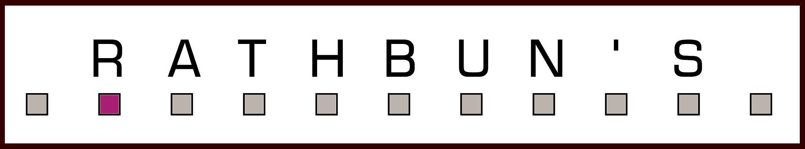

Menu 1 - $50.00 plus tax and gratuity

(3 course dinner)
(Items subject to season availability)

Please select one item from the small plates section.

For the entrée, please select a total of three items that your guest will be able to choose from.

For the side plates, please select two sides. They will be served family style.
For the desserts, please select either one for all or
the platter of four.

SMALL PLATES

Hot Smoked Salmon Tostadas,
Habanero Cream Cheese

Ya Ya Eggplant Fries, 10x Sugar, Tabasco

Roasted Pork Belly Taco, Orange Hoisin, Cilantro

Romaine Heart Salad with Parmesan Crouton

Greek Wedge, Cucumbers, Sweet Peppers
Feta Cheese & Toasted Oregano Vinaigrette

Stove Works Seasonal Soup

BIG PLATES
(select three)

Enchanted Springs Trout
Gnocchi, Radish, Baby Kale

Prestige Farms Chicken
Succotash, Green Goddess

Pinot Noir Braised Short Rib
Slow Cooked Onion, Potato Soubise

Sea Scallop Benedict,
Country Ham Grits, Chile Hollandaise

BIG PLATES, cont’d

Bay of Fundy Salmon
Quinoa, Goat Cheese, Tomato-Caper Olio

8 oz. Filet
French Onion Jus
($10 Supplement)

SIDE PLATES
(select two)

Whipped Potatoes

Truffle Mac n’ Cheese

Creamed Corn & Gouda Cheese

Braised Greens, Pickled Peppers

Local Vegetables

DESSERTS

Banana Peanut Butter Cream Pie

Gooey Toffee Cake
Jack Daniels Ice Cream

Krog Street Candy Bar

Orange Yogurt Cake

(Items subject to season availability)

2/2017

Menu 2 - $60.00 plus tax and gratuity

This menu is Four Courses

Please select one item from the small plates and one item from either the cold or soups area.

For the entrée, please select a total of three items that your guest will be able to choose from.

For the side plates, please select two sides. They will be served family style.
For the desserts, please select either one for all or
the platter of four.

SMALL PLATES

Hot Smoked Salmon Tostadas,
Habanero Cream Cheese

Ya Ya Eggplant Fries, 10x Sugar, Tabasco

Roasted Pork Belly Taco, Orange Hoisin, Cilantro

Stove Works Seasonal Soup

COLD PLATES

Greek Wedge
Feta, Oregano Vinaigrette

Romaine Heart Salad with Parmesan Crouton

BIG PLATES

(select three)

Enchanted Springs Trout
Gnocchi, Radish, Baby Kale

Prestige Farms Chicken
Succotash, Green Goddess

Pinot Noir Braised Short Rib
Slow Cooked Onion, Potato Pave

Maine Lobster and Roasted Green Chile Soft Taco,
Cascabel Cream and Green Tomato Pico

BIG PLATES, cont’d.

Bay of Fundy Salmon
Quinoa, Goat Cheese, Tomato-Caper Olio

8 oz. Tenderloin of Beef
French Onion Jus

SIDE PLATES
(select two)

Whipped Potatoes

Truffle Mac n’ Cheese

Creamed Corn & Gouda Cheese

Braised Greens, Pickled Peppers

Local Vegetables

DESSERTS

Banana Peanut Butter Cream Pie

Krog Street Candy Bar

Orange Yogurt Cake

Gooey Toffee Cake
Jack Daniel's Ice Cream

(Items Subject to seasonality)

2/2017

Menu 3 – $70.00 plus tax and gratuity
This menu is four courses.

Please select one item from the small plates and one

item from either the cold or soup area.

For the entrée, please select a

total of three items that your guest will be able to choose from.

For the side plates, please select two sides. They will be served family style.
For the desserts, please select either one for all or
the platter of four.

SMALL PLATES

Hot Smoked Salmon Tostadas,
Habanero Cream Cheese

Ya Ya Eggplant Fries, 10x Sugar, Tabasco

Roasted Pork Belly Taco, Orange Hoisin, Cilantro

Stove Works Seasonal Soup

COLD PLATES

Greek Wedge
Feta, Oregano Vinaigrette

Romaine Heart Salad with Parmesan Frico

Oysters on the ½ Shell, Traditional Mignonette

BIG PLATES

Prestige Farms Chicken
Succotash, Green Goddess

Sea Scallop Benedict,
Country Ham Grits, Chile Hollandaise

Enchanted Springs Trout
Gnocchi, Radish, Baby Kale

Heritage Pork Chop
Sweet Potato, Kale, Golden Sultana Jus

8 oz. Tenderloin of Beef
French Onion Jus

BIG PLATES, cont’d

Bay of Fundy Salmon
Quinoa, Goat Cheese, Tomato-Caper Olio

20 oz. Bone-In Ribeye,
Sweet Pepper Sofrito

($15 Supplement)

SIDE PLATES

Whipped Potatoes

Truffle Mac n’ Cheese

Creamed Corn & Gouda Cheese

Braised Greens, Pickled Peppers

Local Vegetables

DESSERTS

Banana Peanut Butter Cream Pie

Gooey Toffee Cake
Jack Daniels Ice Cream

Krog Street Candy Bar

Orange Yogurt Cake



Menu 4 - $80.00 plus tax and gratuity
This menu is four courses.

Please select one item from the small plates and one item from the cold and one from the soup.

For the entrée, please select a total of three items that your guest will be able to choose from.

For the side plates, please select two sides. They will be served family style.
For the desserts, please select either one for all or
the platter of four.

SMALL PLATES

Hot Smoked Salmon Tostadas,
Habanero Cream Cheese

Ya Ya Eggplant Fries
10x Powdered Sugar, Tabasco

Roasted Pork Belly Taco
Orange Hoisin, Cilantro

Stoveworks Seasonal Soup

Salt and Pepper Shrimp
Crispy Onion, Cabbage, Aged Soy

COLD PLATES

Thai Rare Beef
Serrano, Red Onion

Greek Wedge
Feta, Oregano

Romaine Heart Salad with Parmesan Crouton

Beef Tartare
Traditional Accompaniments

BIG PLATES

Roasted Maple Leaf Duck Breast
Thai Risotto, Green Curry Jus

Sea Scallop Benedict,
Country Ham Grits, Chile Hollandaise

Big Plates cont’d.

Prestige Farms Chicken
Succotash, Green Goddess

20 oz. Bone-In Ribeye,
Sweet Pepper Sofrito

Maine Lobster and Roasted Green Chile Soft Taco,
Cascabel Cream and Green Tomato Pico

8 oz. Tenderloin of Beef
French Onion Jus

Bay of Fundy Salmon
Quinoa, Goat Cheese, Tomato-Caper Olio

SIDE PLATES

Whipped Potatoes

Truffle Mac n’ Cheese

Creamed Corn & Gouda Cheese

Braised Greens, Pickled Peppers

Local Vegetables

DESSERTS

Banana Peanut Butter Cream Pie

Gooey Toffee Cake
Jack Daniels Ice Cream

Krog Street Candy Bar

Orange Yogurt Cake

2/2017
(Items Subject to seasonality)

Passed Appetizer Selections
09-2016

Vegetable
$2.50 a piece

Vermont Butter Dipped Radish, Sea Salt

Goat Cheese-Wild Mushroom Crostini

Pimiento Cheese Fritters,
Green Tomato Chow Chow, Charred Jalapenos

Chive and Cheddar Croquette, Crema

Seafood
$3.50 a piece

Crispy Oyster, Bourbon Aioli

Garlic Chili Shrimp

Salmon Tostada, Habanero Crème Fraiche

Raw Oyster, Mignonette

Meat
$3.50 a piece

Grilled Beef Skewers, Chimichurri

Chicken Skewers, Blue Cheese Fondue, Sriracha

Duck Rillette, Grilled Bread

Thai Rare Beef

Cocktail Party Menu
$55.00 per person

Passed Appetizers Buffet

Pick 2 (Cold)

Pick 4 (Hot)
Cheddar and Chive Croquettes
Pimiento Cheese Fritters
Garlic Chili Shrimp
Crispy Oyster
Grilled Beef Skewers
Chicken Skewers, Blue Cheese Fondue

Pick 3 (Cold)
Raw Oyster, Mignonette
Goat Cheese with Wild Mushroom Crostini
Vermont Butter Dipped Radish, Sea Salt
Hot Smoked Salmon Tostada
Duck Rillete, Grilled Bread

Romaine Hearts, Parmesan, Anchovy
Thai Rare Beef, Serrano, Red Onion
Greek Wedge, Feta, Oregano Vinaigrette
Arugula, Squash, Radicchio, Ricotta Salata

Pick 2 (Hot)
Braised Short Rib, Risotto French Onion Jus
Roasted Chicken Breast, Whipped Potatoes, Braised Greens
Slow Roasted Pork Belly, Charred Cream Corn, Broccoli Rabe
Georgia Shrimp, Country Ham Grits, Bourbon Hollandaise, Garlic Chips
Enchanted Springs Trout, Jasmine Rice, Crispy Lemon, Salsa Verde
Bay of Fundi Salmon, Quinoa, Goat Cheese Cranberry Glaze

Desserts

Pick 4
Vanilla Bean Panna Cotta
Lemon Mousse
Creamy Caramel Tart
Chocolate Assortment
Mini Fruit Tart
Assorted Cookies
Mini Cup Cakes
Double Dark Chocolate Pudding
Mini Banana Peanut Butter Cream Pies
Fruit or Chocolate Cream Puffs

